Template Resource

📝Definition
# Source: AI Source: Provided by: [Data Path: Persons Table -> ID Column: 1, Name_En Column: Motasem Essam] -> From: [ChatGPT] on [1/23/2026]
A Template Resource is a predefined UI structure or layout used to display data consistently across an application. It defines how content should look, while the actual data is provided dynamically (from ViewModel, Controller, or Model).
👉 Think of a Template as a UI blueprint — it shows where and how data appears, but not the data itself.

🔑 Key Points
# Source: AI Source: Provided by: [Data Path: Persons Table -> ID Column: 1, Name_En Column: Motasem Essam] -> From: [ChatGPT] on [1/23/2026]
- Defines layout and structure of UI
- Displays dynamic data
- Promotes reusability and consistency
- Keeps presentation separate from logic

🧱 Examples

1️⃣ HTML Template Example
# Source: AI Source: Provided by: [Data Path: Persons Table -> ID Column: 1, Name_En Column: Motasem Essam] -> From: [ChatGPT] on [1/23/2026]
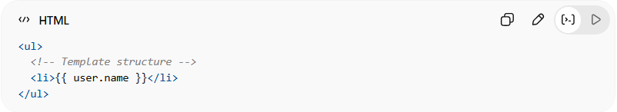
<ul>
<!-- Template structure -->
<li>{{ user.name }}</li>
</ul>
👉 Here:
- <li> is part of the template structure
- {{ user.name }} is dynamic data binding

2️⃣ Laravel Blade Template
# Source: AI Source: Provided by: [Data Path: Persons Table -> ID Column: 1, Name_En Column: Motasem Essam] -> From: [ChatGPT] on [1/23/2026]
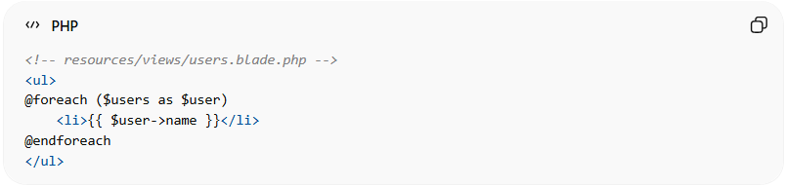
<!-- resources/views/users.blade.php -->
<ul>
@foreach ($users as $user)
<li>{{ $user->name }}</li>
@endforeach
</ul>
👉 Here:
- Blade file is a Template Resource
- Receives $users from Controller
- Only handles presentation

3️⃣ Component-Based Template (React)
# Source: AI Source: Provided by: [Data Path: Persons Table -> ID Column: 1, Name_En Column: Motasem Essam] -> From: [ChatGPT] on [1/23/2026]
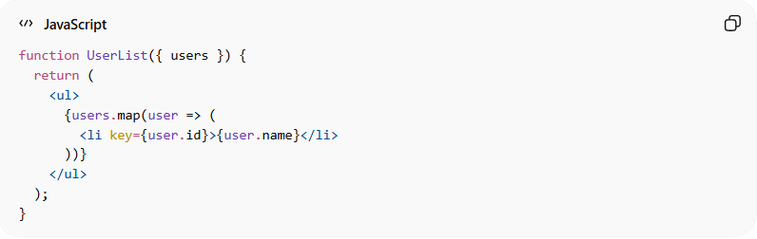
function UserList({ users }) {
return (
<ul>
{users.map(user => (
<li key={user.id}>{user.name}</li>
))}
</ul>
);
}
👉 Here:
- Component acts as a reusable template
- Receives data via props

❌ Bad Example
# Source: AI Source: Provided by: [Data Path: Persons Table -> ID Column: 1, Name_En Column: Motasem Essam] -> From: [ChatGPT] on [1/23/2026]
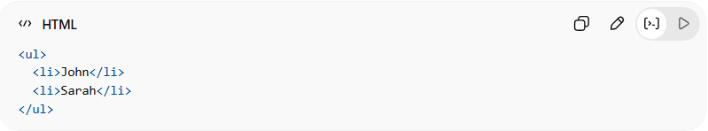
<ul>
<li>John</li>
<li>Sarah</li>
</ul>
Problems:
- Hardcoded data ❌
- Not reusable ❌
- Not dynamic ❌

✅ Good Example
# Source: AI Source: Provided by: [Data Path: Persons Table -> ID Column: 1, Name_En Column: Motasem Essam] -> From: [ChatGPT] on [1/23/2026]
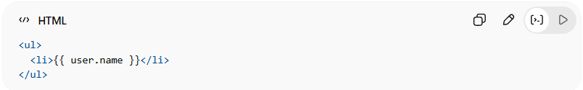
<ul>
<li>{{ user.name }}</li>
</ul>
- Dynamic data binding ✅
- Reusable structure ✅
- Clean separation of concerns ✅

🔄 Relation to Other Resources
# Source: AI Source: Provided by: [Data Path: Persons Table -> ID Column: 1, Name_En Column: Motasem Essam] -> From: [ChatGPT] on [1/23/2026]
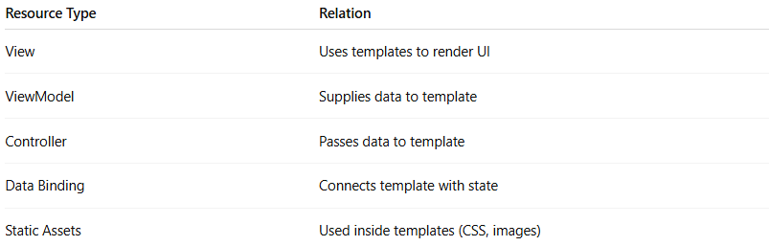
Resource Type | Relation
View | Uses templates to render UI
ViewModel | Supplies data to template
Controller | Passes data to template
Data Binding | Connects template with state
Static Assets | Used inside templates (CSS, images)

⚠️ Common Mistakes
# Source: AI Source: Provided by: [Data Path: Persons Table -> ID Column: 1, Name_En Column: Motasem Essam] -> From: [ChatGPT] on [1/23/2026]
- Hardcoding data inside templates ❌
- Adding business logic in templates ❌
- Making templates too complex ❌

💡 Key Idea
# Source: AI Source: Provided by: [Data Path: Persons Table -> ID Column: 1, Name_En Column: Motasem Essam] -> From: [ChatGPT] on [1/23/2026]
A Template Resource defines how data is displayed, keeping UI clean, reusable, and separated from logic.

🧾 Summary
# Source: AI Source: Provided by: [Data Path: Persons Table -> ID Column: 1, Name_En Column: Motasem Essam] -> From: [ChatGPT] on [1/23/2026]
- Defines UI layout
- Displays dynamic data
- Used by View layer
- Keeps presentation separate from logic

